**CIS 310-50**

**Database Design**

**Assignment #2**

This MS Access 2019 Assignment is worth 50 points.

Part 1. Create the Employee database as described on page 107 of the textbook. It is recommended that you first determine the answers to questions 10-16 on page 107 before attempting to build the database. You must establish all the relationships between four tables and enforce entity integrity and referential integrity where appropriate. You should not allow cascade on delete and allow cascade on update. (These concepts are covered in detail in chapters 3 and 4. I will go over them briefly in the Panopto recording so that you could complete this project. Populate the database with the given data.

Part 2. Create two forms for the database.

The first form is called Employee_Form. This form will be used to maintain the employee data in the Employee table. The form must have buttons for Add, Delete, and Find operations. Use the Columnar format to display data in this form.

The second form is called Plan_Form. In this form you should provide the user with the ability to browse the employee information by plan. You should use a subform to display the employees in each plan. Show all fields for each employee. Use the Tabular format to display data in this form.

I am assuming that some of these concepts were covered in the CIS-305 course.

Submit the project via Blackboard by the given deadline. The file name must be Assignment2_YourLastName_YourFirstName.accdb (example: Assignment2_Zurada_Jozef.accdb).

Note: When you design the tables, you should give each attribute a meaningful name, the appropriate data type, and brief description. Customize the tables and the forms. In the tables the names of attributes should be fully displayed. Each form should have a meaningful title and clearly display all required data. Each of the three buttons on the Employee form should have a meaningful name or picture icon explaining what the button does.

Example of the Employee Form

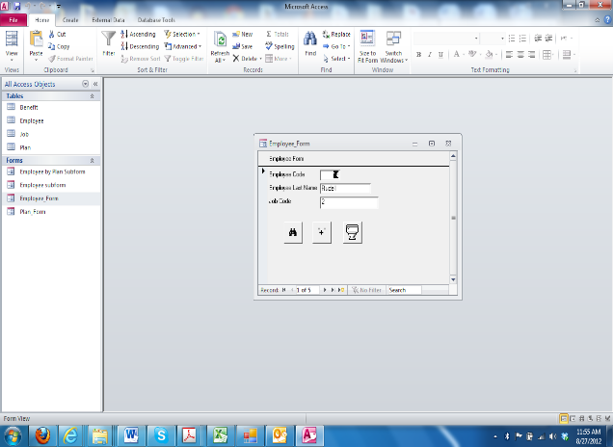

Example of the Plan Form

